**How to Install RemoteStaff Screen Capture (RSSC) for Windows Users**

1. Uninstall the old version of RemoteStaff Screen Capture (RSSC) by going to your control panel. If you need help in doing this contact your Staffing Consultant.
2. Locate the ThinkInnovationsInstaller.exe you previously downloaded and double click it. Refer to image below.

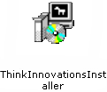

1. Click on RUN to begin the installation. Refer to image below.

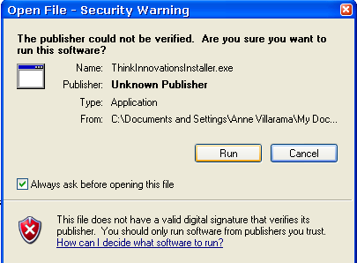

1. Check or uncheck on the component you want to install then click NEXT to continue.

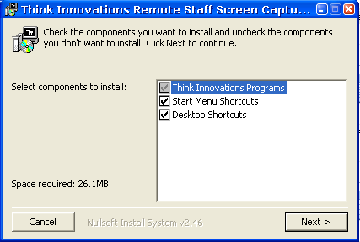

1. The installer will tell you where the RemoteStaff Screen Capture (RSSC) will be installed. You can also click the BROWSE button to select a folder of your choice. Click INSTALL button to proceed.

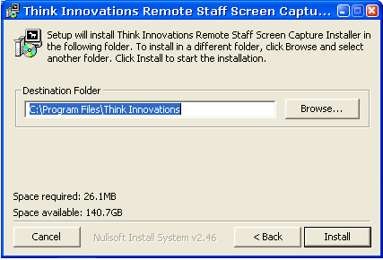

1. Wait a few minutes to complete the installation. When complete, close the window and locate the RemoteStaff Screen Capture (RSSC) Icon on your desktop or chosen folder.

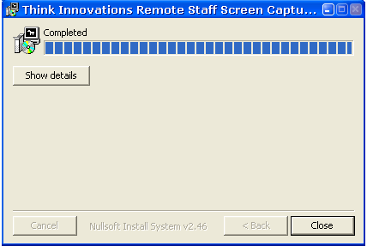

1. **Note for Windows user:** If you encountered ***"application configuration is incorrect"***, kindly download and install redistributable package first. You can download the redistributable package from [here.](http://www.microsoft.com/downloads/en/details.aspx?familyid=A5C84275-3B97-4AB7-A40D-3802B2AF5FC2&displaylang=en)